Resumos TPW - AT1

1. Web Application Architectures 1
1.1 - Data Independence in Databases 1
1.2 - N-Tier Architectures 2
1.2 - Design Patterns 4
1.2.1 - The MVC Design Pattern 4
2. Django I 6
2.1 - Views 6
2.2 - Templates 6
2.3 - Static Files 6
3. Django II 7
3.1 - Models 7
3.2 - Django’s Database Layer 8
4. Django III 9
4.1 - Envio/Receção de Dados - Forms 9
5. Django Framework 11
5.1 - Django Forms 11
5.2 - Django Authentication 12
5.3 - Django Sessions 14
6. Production 15
6.1 Web Applications Deployment 15

1. Web Application Architectures

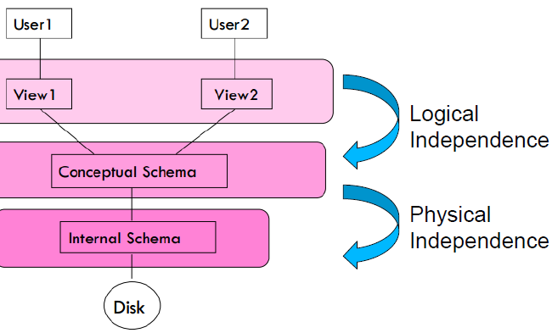
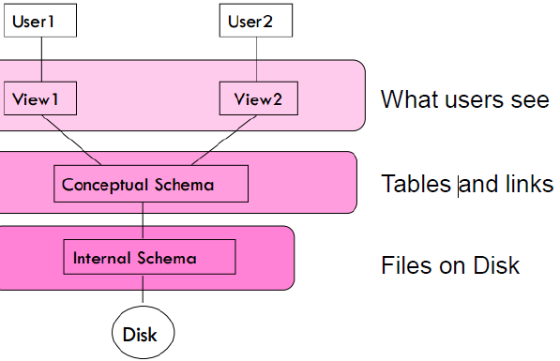
1.1 - Data Independence in Databases
- Each level is independent of the levels below

- Logical Independence
Change the logical schema without changing the external schema or application programs
- Can add new fields, new tables without changing views
- Can change structure of tables without changing view

- Physical Independence
Change the physical schema without changing the logical schema
- Storage space can change
- Type of some data can change for reasons of optimization

What to learn:
- Keep the VIEW: (what the user sees)
- Independent of the MODEL: (domain knowledge)

1.2 - N-Tier Architectures
N-Tier have the same components:
- Presentation, Business/Logic, Data.
N-Tier try to separate the components into different tiers/layers:
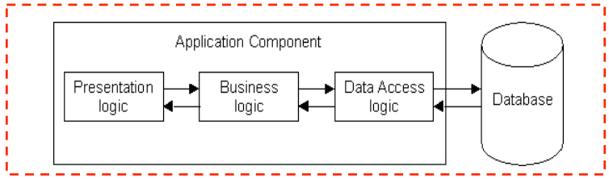
- Tier: physical separation
- Layer: logical separation

1 - Tier Architecture
All 3 layers are on the same machine: all code and processing.
Presentation, Logic, Data layers are tightly connected:
- Scalability: Single processor means hard to increase volume of processing
- Portability: Moving to a new machine may mean rewriting everything
- Maintenance: Changing one layer requires changing other layer
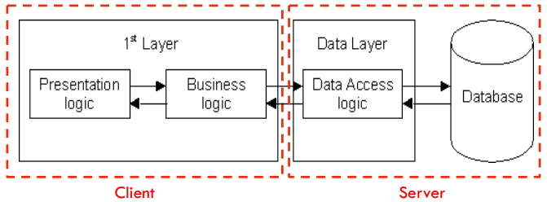
2 - Tier Architecture
Database runs on Server.
- Separated from client
- Easy to switch to a different database
Presentation and logic layers still tightly connected:
- Heavy load on server
- Potential congestion on network
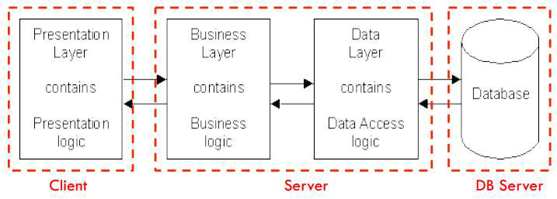
- Presentation still tied to business logic

3 - Tier Architecture
Each layer can potentially run on a different machine.
Presentation, logic, and data layers are disconnected.

- Architecture Principles
- Client - Server Architecture
- Each layer: independent, not expose dependencies of the implementation
- Unconnected layers do not connect
- Changes only affects the layer running on that particular platform

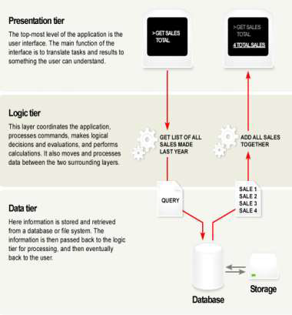
- Presentation Layer (Front-end):
- User Interface: Handles Interaction
- Should not contain business logic or data access code

- Logic Layer (middleware/back-end)
- Set of rules for processing information
- Can accommodate many users
- Should not contain presentation or data access code

- Data Layer (back-end):
- The physical storage layer for data persistence
- Manages access to DB or file system
- Should not contain presentation or business logic code

- 3-Tier Architecture Web Apps
Presentation Layer
- Static or dynamically generated content rendered by the browser (front-end)
Logic Layer
- A dynamic content processing and generation level application server, e.g., Python Django Framework (middleware)
Data Layer
- A database, comprising both data sets and the database management system or RDBMS software that manages and provides access to the data (back-end)

- 3-Tier Architecture – Advantages
Independence of Layers
- Easier to maintain
- Components are reusable
- Faster development (division of work):
  - Web designer does presentation
  - Software engineer does logic
  - DB admin does data model

1.2 - Design Patterns

Construction and testing
- how do we build a web application?
- what technology should we choose?
Re-use
- can we use standard components?
Scalability
- how will our web application cope with large numbers of requests?
Security
- how do we protect against attack, viruses, malicious data access, denial of service?
Different data views
- user types, individual accounts, data protection

Design Pattern:
- general and reusable solution to a commonly occurring problem in the design of software
- template for how to solve a problem that has been used in many different situations
- NOT a finished design
  - The pattern must be adapted to the application
  - Cannot simply translate into code

1.2.1 - The MVC Design Pattern
Design Problems:
- Need to change the look-and-feel without changing the core/logic
- Need to present data under different contexts, etc…

Design Solution:
- Separate core functionality from the presentation and control logic that uses this functionality
- Allow multiple views to share the same data model
- Make supporting multiple clients easier to implement, test, and maintain

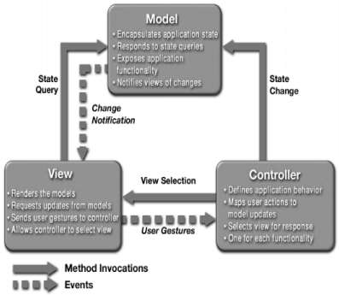
The Model-View-Controller Pattern

- Design pattern for graphical systems that promotes separation between model and view
- The logic required for data maintenance (database) is separated from how the data is viewed (graph, numerical) and how the data can be interacted with (GUI, command line, touch)

Model
- manages the behavior and data of the application domain
- responds to requests for information about its state (usually from the view) follows instructions to change state (usually from the controller)
- Contains domain-specific knowledge
- linked to a database
- Independent of view

View
- renders the model into a form suitable for interaction, typically a user interface (multiple views can exist for a single model for different purposes)
- Presents data to the user
- Allows user interaction

Controller
- receives user input and initiates a response by making calls on model objects
- accepts input from the user and instructs the model and viewport to perform actions based on that input
- defines how user interface reacts to user input (events)
- receives messages from view (where events come from)
- sends messages to model (tells what data to display)

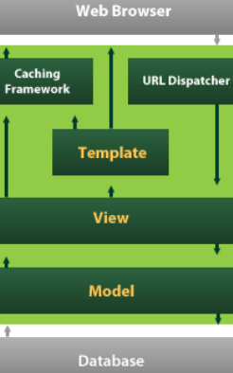
2. Django I
Segue arquitetura MVC
Possui ORM (Object Relational Mapper)

Arquitetura
- Models: Descreve os dados
- Views: Controla o que os users vêm
- Templates: Controla como o vêm
- URL Dispatcher: Expedidor de URLs

2.1 - Views
- Create views in views.py as:
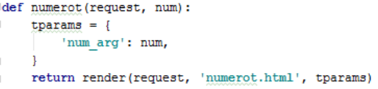

- No urls.py adicionar route para a view

2.2 - Templates
Argumento/Variável: { { num_arg } }
Template Tags: {% ifequal num_arg 1000 %} / {% else %} / {% endifequal %}

2.3 - Static Files
Os static files são ficheiros que se pretende simplesmente referenciar e servir ao cliente, sem qualquer processamento prévio.
- Imagens, CSS, Scripts

3. Django II

3.1 - Models
MTV - Model, Template, View
Model: Camada de acesso aos dados
Permite definir acesso, validação, comportamento, relações entre os dados.

No file models.py definir classes do modelo de dados.
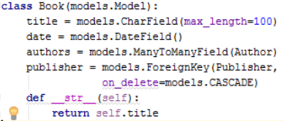

Relações entre as classes:
1:M e M:1
- Atributo da classe models.ForeignKey
  - Publisher (1) : (M) Book
  - O atributo é colocado na classe Book (M), aquela que representa muitos objetos para um.

1:1 (Único)
- Atributo da classe models.OneToOne
  - Exemplo: Book (1) : (1) Author
  - O atributo “deve” ser colocado na classe que mais “necessita” da outra

M:N
- Atributo da classe models.ManyToManyField
  - Book (M) : (N) Author
  - O atributo “deve” ser colocado na classe que mais “necessita” da outra
    - (No presente exemplo, o autor pode existir, por si, sem necessidade de ter livros, mas o livro necessita de um autor)

3.2 - Django’s Database Layer

Django Admin Site: Gestão dos dados pertencentes ao modelo de dados.
Na admin.py registar as classes a gerir:
admin.site.register(Author)

- Inserir um objeto
  - a = Author(name=‘Antonio Pedro’, email=’apedro@email.com’)
  - a.save()
- Modificar um objeto
  - a.email = ‘antonio.pedro@email.com’
  - a.save()
- Selecionar todos os objetos
  - Autor.objects.all()
- Filtrar objetos (por nome)
  - Autor.objects.filter(name=‘Author1’)
- Filtrar por nome e por email
  - Author.objects.filter(name=‘Autor1’, email=‘...’)
- Filtrar por nome parecido
  - Author.objects.filter(name_contains=‘Autor’)
- Aceder a um único objeto
  - Author.objects.get(email=‘autor1@email.com’)
- Ordenação
  - Publisher.objects.order_by(“city”, “country”)
- Filtragem e Ordenação
  - Publisher.objects.filter(country=‘Portugal’).order_by(“-city”)
- Selecionar os primeiros resultados
  - Publisher.objects.order_by(“city”, “country”)[0]
  - Publisher.objects.order_by(“city”, “country”)[0:4]
  - Não são permitidos índices negativos
- Remover um objeto
  - Author.objects.get(email=‘autor1@email.com’).delete()

4. Django III

4.1 - Envio/Receção de Dados - Forms
Objeto “request” do tipo “HttpRequest” permite aceder a dados recebidos pelo web server
Podem ser acedidos através de atributos e métodos dedicados (request.path(), ex.)

View para aceder a dados no header HTTP
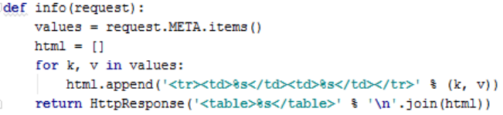

FORMS
Forms servem para envio/receção de dados cliente <-> servidor
- Lado do cliente: forms podem ser usados para Get ou Post
- Lado do servidor: request.GET e request.POST para aceder aos dados

Exemplo:
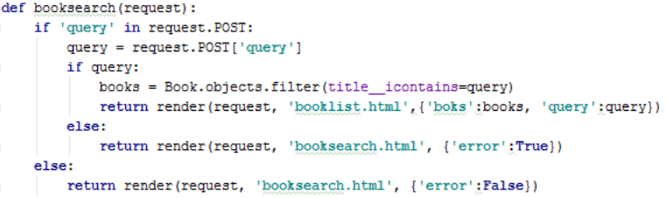

Pesquisa:
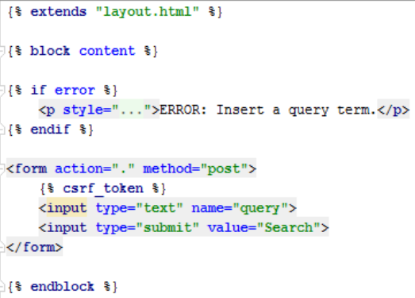

Resultados pesquisa:
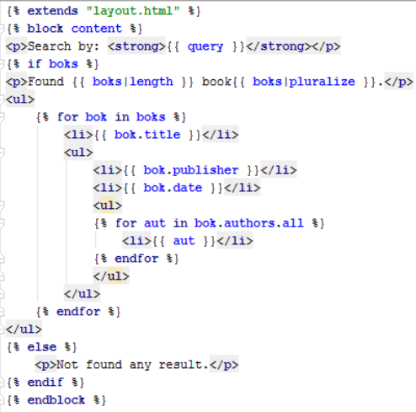

5. Django Framework

5.1 - Django Forms
Form class: describes a form and determines how it works and appears in the browser.
Form class instantiation we can populate it:
- data from a saved model instance (as in the case of admin forms for editing);
- data that we have collated from other sources;
- data received from a previous HTML form submission.

Creating a Django Form
forms.py:
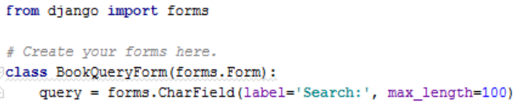
bookquery.html:
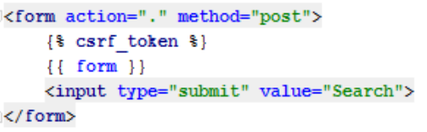
views.py
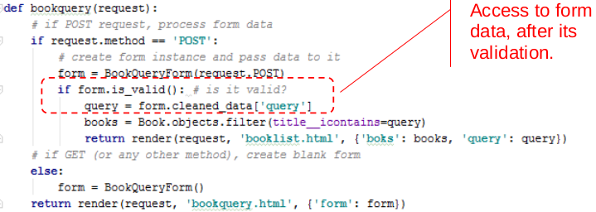

Data Field
- Data submitted with a form, using Form Fields, can be validated through is_valid() function.
- After validation, data can be accessed in form.cleaned_data dictionary.
- The data in this dictionary is already converted into Python types, for immediate use.
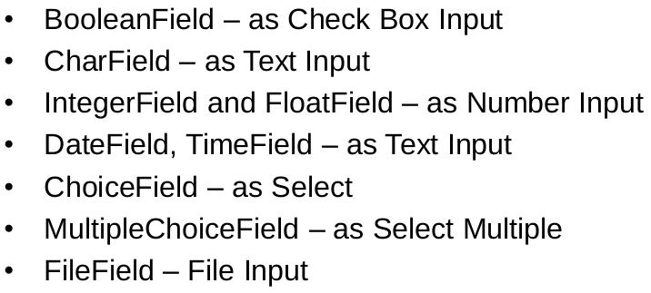
Rendering Form Fields Individually:
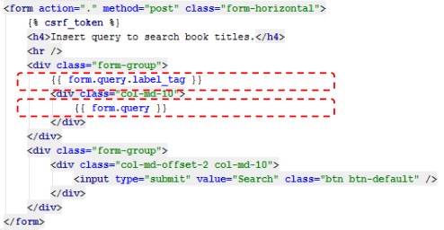

5.2 - Django Authentication
It handles both authentication and authorization.
- Authentication verifies if users are who they claim to be.
- Authorization determines what authenticated users are allowed to do.
Implements: Users, groups, permissions, forms, view tools, password hashing.

Create Login and Logout (urls.py)
login.html
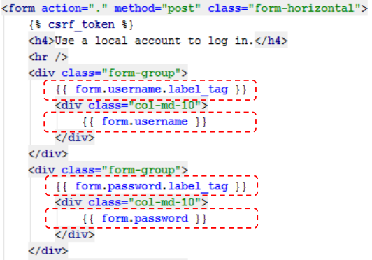
Authorization
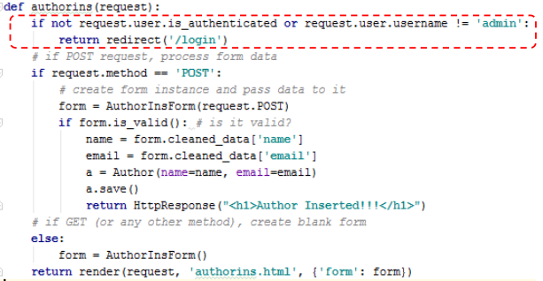
Through object “request.user”, it’s possible to verify if a given user is authenticated and have authorization to do operations.

5.3 - Django Sessions

State
- HTTP protocol is a stateless protocol, which means that it doesn’t have any mechanism to save the connection state and as so it doesn’t allow sessions creation.
- To do this, some exterior mechanisms were developed in web clients and servers, which allow to save state data over multiple HTTP connections, producing artificial sessions.
Like: Cookies

Cookies
- A cookie is a little piece of information sent by a web server to its client, a browser, to save it while they are in communication.
- It’s possible to save some kind of information in this cookie, like the user’s username, for example.
- This cookies mechanism is in wide use by almost web sites, but it has some disadvantages:
- Saving cookies in the browser is not compulsory, which doesn’t allow to offer warranty of a good service;
- They can’t be used to save important information – they aren’t secure;
- The server can be inhibited, at some time, to access crucial information to continue the interaction with the client.

Django Sessions:
- Django manage automatically the sessions with its clients in a simple and clean way, through “request.session” object, which is a dictionary.
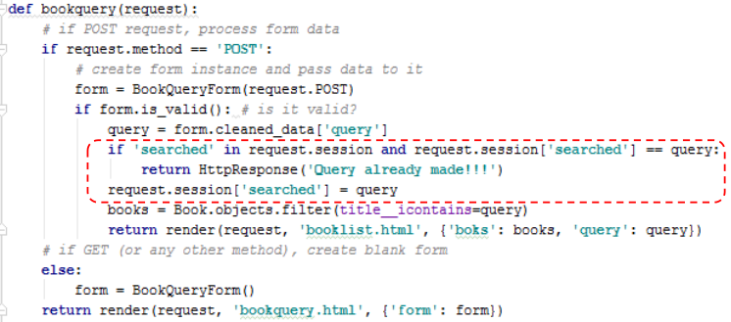

6. Production

6.1 Web Applications Deployment

Production Environment:
- Environment provided by the server computer where you will run your web application for external consumption.
Includes:
- Computer Hardware
- OS
- Programming Language
- Web server
- Application server
- Databases

- The server computer could be located on your own facility and connected to the Internet by a fast link
OR
- Use a server computer that is hosted "in the cloud“.

IaaS
Infrastructure as a Service – is a remotely accessible computing/networking hardware, provided as a hosting service.
- Many IaaS providers offer options to preinstall a particular operating system, onto which you must install the other components of your production environment.
- Other vendors allow you to select more fully-featured environments, including a complete particular web framework, e.g Django, and a web-server setup

PaaS
Platform as a Service – is another kind of hosting service where the host platform takes care of:
- most of the production environment – web server, application server, load balancers;
- and most of what you need to scale the application.
- PaaS makes deployment quite easy, because you just need to concentrate on your web application and not all the other server infrastructure.

Choosing a Hosting Service
Issues to take in account:
- How busy your site is likely to be and the cost of data and computing resources required to meet that demand.
- Level of support for scaling horizontally (adding more machines) and vertically (upgrading to more powerful machines) and the costs of doing so.
- Where the supplier has data centers, and hence where access is likely to be fastest.
- The host's historical uptime and downtime performance. • Tools provided for managing the site — are they easy to use and are they secure (e.g. SFTP vs FTP).
- Inbuilt frameworks for monitoring your server. Known limitations. Some hosts will deliberately block certain services (e.g. email). Others offer only a certain number of hours of "live time" in some price tiers, or only offer a small amount of storage.
- Additional benefits. Some providers will offer free domain names and support for SSL certificates that you would otherwise have to pay for.
- Whether the "free" tier you're relying on expires over time, and whether the cost of migrating to a more expensive tier means you would have been better off using some other service in the first place!

